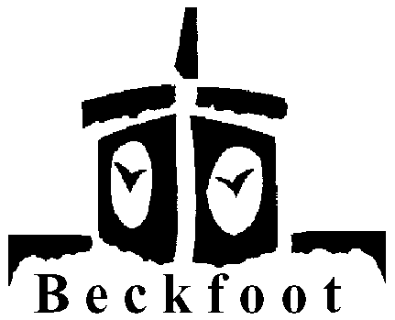 MFL

Year 7 Lesson Plan 3 Half Term 1

Topic – Cultural introduction

Connect
(AS students enter room, CD/tape of G/F music playing – chart dance music is good! Don’t make a big issue of this here though.)

Students answer the register with a G/F word they have learned so far.

Resources
Possible resources include: CD/tape, sweets, map internet and whiteboard if available, coins, any realia from TL

Big Picture
Learning German/French, but also about the language and the people who speak it.

Learning outcomes
All students will know 3 NEW facts about TL/TLCountry to pass on to others.

Input and activities
Mainly from students themselves – previous lesson’s homework to find out 3 facts about TLCountry or TL. Elicit these from students in organised manner, perhaps in sections of history, geography, food, culture. Divide board/flipchart into similar sections and keep note (or get a student to) with key words.

TIPS
- Use the interactive map of Europe on www.yourchildlearns.com/map-europe when looking at geography – students can guess where countries mentioned are
- Go quickly when doing history, and draw silly maps to help. If you tell students they’ll have to really try to keep up and present with enthusiasm bordering on the manic they’ll be enthralled. Keep a check with easy ‘I’m checking if you’re listening questions’
- If you have an interactive whiteboard, look up pictures of places the students mention (the alps etc) to give them an instant visual idea of what’s being discussed

Demonstrate
Students (using key words on board as prompt if necessary) tell neighbour 3 facts they didn’t know at start of lesson.

Review
T picks students to relay their partner’s 3 new facts to class.

Preview
Moving on to asking and giving ages, starting with numbers.

